This early man lived in Africa.
Early man did not have sharp claws or strong sharp teeth. He was not larger or stronger than other animals. He could not run like deer or antelope. So how did early man survive?
He had to use the things that animals did not have, reason and invention. Early man invented and created stone and bone weapons and tools. With these tools, early man could kill and trap those animals he needed for food. With stone axes and spears, he could defend against those animals that thought he might be food. Since many of the tools he created were made out of stone, this is called the Stone Age.
The Stone Age is considered to have begun about two million years ago, and ended sometime after the end of the last ice age about ten thousand years ago.
During the stone age, Homo Habilis appeared. These early people were mostly vegetarian eating fruits, nuts, berries and occasionally fish and animals they hunted. They were not great hunters due to the crude construction of their spears and axes, but they did get the job done.
Some scientists believe that Homo Habilis did not know how to start a fire. Homo Habilis did use fire and made campfires, but these were probably started by finding something that was already burning from a lightning strike.
Campfires were very useful to homo Habilis since fire keeps most animals away, so a campfire would be watched carefully to keep it going. Some people have called Homo Habilis cave men. This is probably not true. Since they had to move constantly to find food to eat, they could not settle down in one place. Caves are also home to some very mean predators such as bears and lions so Homo Habilis probably avoided caves.
http://earlyhumans.mrdonn.org/tools.html

Early Stone Age Tools
The earliest stone toolmaking developed by at least 2.6 million years ago. The Early Stone Age includes the most basic stone toolkits made by early humans. The Early Stone Age in Africa is equivalent to what is called the Lower Paleolithic in Europe and Asia.
The oldest stone tools, known as the Oldowan toolkit, consist of at least:
• Hammerstones that show battering on their surfaces
• Stone cores that show a series of flake scars along one or more edges
• Sharp stone flakes that were struck from the cores and offer useful cutting edges, along with lots of debris from the process of percussion flaking
By about 1.76 million years ago, early humans began to strike really large flakes and then continue to shape them by striking smaller flakes from around the edges. The resulting implements included a new kind of tool called a handaxe. These tools and other kinds of ‘large cutting tools’ characterize the Acheulean toolkit.
The basic toolkit, including a variety of novel forms of stone core, continued to be made. It and the Acheulean toolkit were made for an immense period of time – ending in different places by around 400,000 to 250,000 years ago.
Explore some examples of Early Stone Age tools.

Hammerstone
Hammerstone from Majuangou, China

Core
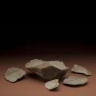  Oldowan Tools from Lokalalei, Kenya | 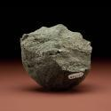  Olduvai Chopper | 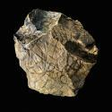  Stone Tools from Majuangou, China | 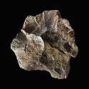  Stone Tools from Majuangou, China

Handaxe
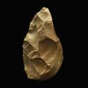  Handaxe and Tektites from Bose, China | Handaxe and Tektites from Bose, China | 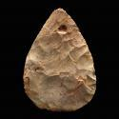  Handaxe from Europe | 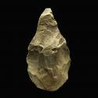  Handaxe from India
© Copyright Smithsonian Institution

STONE AGE TOOLKIT
About 40,000 years ago, near the dawn of the 30-millennia-long period known as the Upper Paleolithic, the first anatomically modern humans suddenly and mysteriously revolutionized their cultures with dozens of specialized tools, weaponry, and other artifacts. They became deft hunters capable of bringing down massive animals, they tolerated harsh environmental conditions, and they equipped themselves to travel vast distances in search of new frontiers. Many questions still remain about these peoples, including when and how they journeyed to the New World, but experts agree that the answers could someday crystallize from the ever-emerging technological evidence Stone Age humans left behind. Here, consider what roles 10 different kinds of primitive artifacts from Europe and North America played for our earliest ancestors.—Lexi Krock

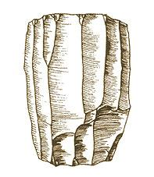 |  | Blade Core  This artifact was used to provide stone blades.  Blade cores provided a portable source of stone or obsidian for manufacturing different kinds of tools by flaking off pieces from the core. The basis of many Upper Paleolithic tool forms from both the Old and New Worlds was the blade flake, a thin, parallel-sided flake that is at least twice as long as it is wide. Blade flakes were "pre-forms" that could be fashioned into knives, hide scrapers, spear tips, drills, and other tools.
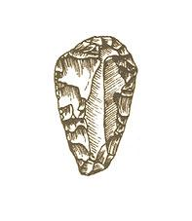 |  | End Scraper  This artifact was used for scraping fur from animal hides.  For European and American Stone Age peoples, end scrapers served as heavy- duty scraping tools that could have been used on animal hides, wood, or bones. Once the hide was removed from an animal, an end scraper could take the hair off the skin's outer layer and remove the fatty tissue from its underside. End scrapers were sometimes hafted, or attached to a wooden handle, but could also be handheld.
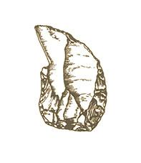 |  | Burin  This artifact was used for carving bone, antler, or wood.  Burins are among the oldest stone tools, dating back more than 50,000 years, and are characteristic of Upper Paleolithic cultures in both Europe and the Americas. Burins exhibit a feature called a burin spall—a sharp, angled point formed when a small flake is struck obliquely from the edge of a larger stone flake. These tools could have been used with or without a wooden handle.
Awl
This artifact was used for shredding plant fibers.
Awls were small, pointed hand tools employed in both the Old and New World to slice fibers for thread and fishing nets, and to punch holes in leather and wood. Stone Age peoples may also have sliced animal hides to make clothing using awls. These tools could be made from stone or bone and were highly sharpened for maximum efficiency.

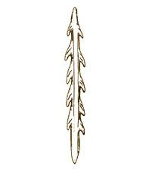 |  | Antler Harpoon  This artifact was used for hunting large marine animals.  Upper Paleolithic cultures in Europe between 20,000 and 10,000 years ago hunted seals, whales, and even swimming land mammals such as reindeer using antler harpoons. In the New World, these harpoons appeared only around 6,000 years ago in the arctic cultures of Alaska and Canada. Experts believe antler harpoons were used in tandem with wooden launchers known as atlatls to help the harpoon penetrate prey with more force.
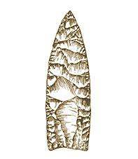 |  | Clovis Point  This artifact was used for killing mammoths and other megafauna.  Clovis refers to this particular style of stone spear point and to the culture of the North American people who used such weapons to devastating effect against large game. Clovis points are leaf-shaped and have a wide groove, or flute, on both sides of the base for fitting into short wooden or bone spear shafts. The largest spear point ever found, measuring nine inches long, was a Clovis point made of chalcedony, a kind of quartz.
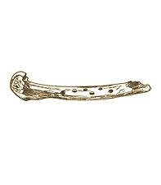 |  | Bone Flute  This artifact was used for playing music.  Made of bone, this wind instrument dates to around 14,000 years ago in France. Hunters may have carried such flute-like instruments in their mobile toolkits or been buried with them, perhaps for the afterlife. Other artistic relics of Stone Age peoples, especially in the Old World, include carved figurines, cave paintings, and beaded clothing. France's Solutrean culture of 23,000 to 18,000 years ago is noted for its artistic tradition.
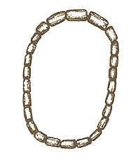 |  | Beads  This artifact was used for personal ornamentation.  It's impossible to know definitively, but experts think beads made of bone, ivory, shells, and teeth were decorative and might also have been traded as currency, based on what they know about the cultures of contemporary native peoples. They have unearthed necklaces, pendants, bracelets, and anklets at Stone Age weapons caches and burial sites in Europe and the Americas.
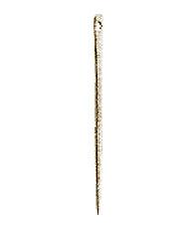 |  | Needle  This artifact was used for stitching hides.  Stone Age technology included delicate sewing needles made of bone with punched eyeholes. They were probably used in tandem with thread fashioned from plant fibers or animal sinew. Archeologists have found bone needles dating to within the past 20,000 years in Europe and North America, where they might have facilitated clothing and boat production.
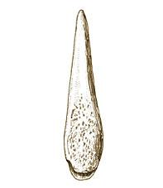 |  | Bone Point  This tool was used for launching at animals during hunting.  Bone projectile points were flexible, light, general-purpose weapons for hunting large land animals. To be as lethal as possible, their tips were chiseled to exquisite sharpness. This is a North American point, but bone points hafted onto wooden or bone handles were also common in the Stone Age Old World. A deep groove cuts into the base of the point, where a hunter would have inserted a wooden thrower and secured it with resin.
Note: This feature originally appeared on NOVA's America's Stone Age Explorers website in 2004, when Lexi Krock was an associate editor of NOVA Online.
http://www.pbs.org/wgbh/nova/clovis/tool-nf.html

http://www.sliammonfirstnation.com/archaeology/stonetool.html
Use this website for tools early man made/used
Have students research these web sites and print out pics and names of tools.

http://pnwboces.org/cesar/Curriculum_Center/SSELA/SixthGrade/pdf_files/Unit1/U1_L3_Comparison-Chart.pdf
Comparison Chart: Paleolithic Humans vs. Neolithic Humans

https://www.youtube.com/watch?v=MYbDJF_gMtw&feature=youtu.be
You Tube Video “Stone Age”
Create graphic organizer to go with this

https://www.youtube.com/watch?v=CJLHewx6PHQ
You Tube Video “From Hunter Gatherer to Farmer”
Create graphic organizer to go with this

http://pnwboces.org/cesar/Curriculum_Center/SSELA/SixthGrade/pdf_files/Unit1/U1_L3_Checklist.pdf
Check list for Poster or PPt

