The Hunter Gatherer's Story
"Ahhh! I am tired... it's time to get back, I've been gathering roots and fruits for our supper. I've walked a long way in the forest and along the beach. The beach and the river banks are the best things to follow to go inland, and sometimes I can find animal tracks to get me through the trees.
Before I left we had also spent some time collecting enough wood for the fire and freshwater for cooking at our camp. We have to do this every day.

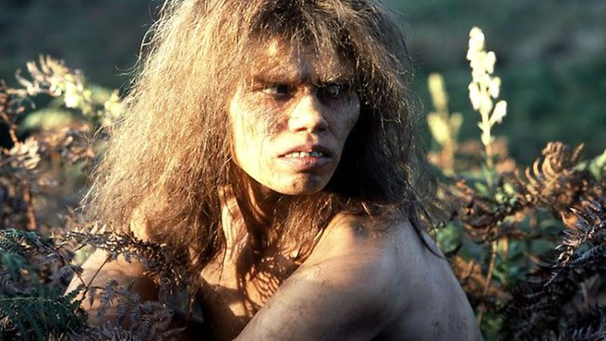

Near my camp I feel safe - we light fires to keep us warm and to keep the bears and wolves away at night. Sometimes, when the menfolk and our brothers go off to trap birds and hunt deer in the forest, we go with our mother to collect shellfish, seabirds eggs and seaweed from the shore to bring home.

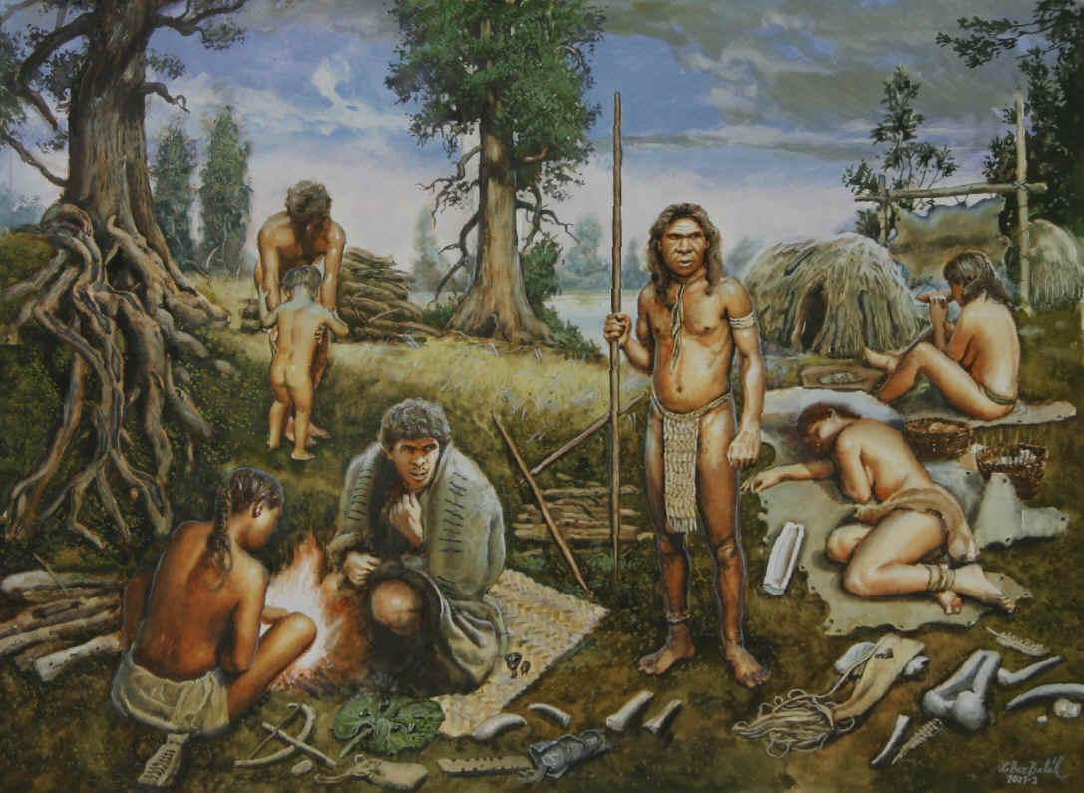

My mother also finds wild plants that make us better when we feel ill, or get bad injuries. We also enjoy helping to make useful things from dead plants and animals - it's amazing the variety of things we can make, everything we need!

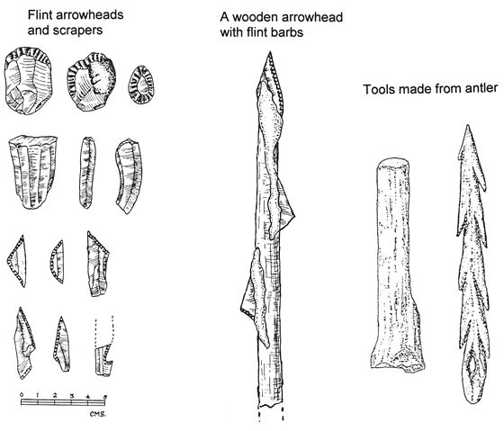

We must return to the camp before dark, we all have a meal together before it gets dark - I like the deer meat best. I am afraid of the dark anyway, but I love the full moon and the twinkling stars. I think everyone is always tired by the time it is dark and we all fall asleep around the fire. Sometimes, I wake up in the night and look out at the moon and the stars - it's wonderful listening to the waves on the beach, and imagining what created the moon and stars!

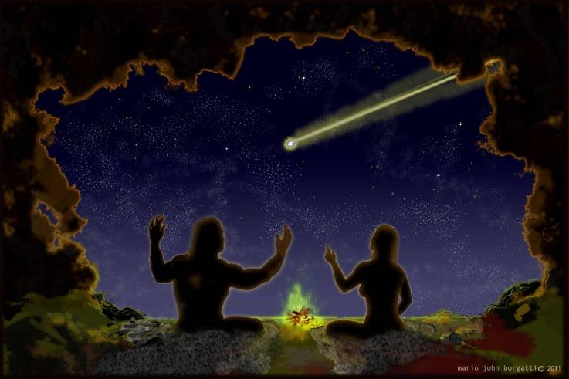

Name: _______________________

Date: ____/____/____

Sequence the Events

Cut out the sentences below.

Paste the events in order as they happened in the story.

I feel safe near my camp. We light fires to keep us warm and to keep the bears and wolves away at night.

I love the full moon and twinkling stars.

I gathered roots and fruits for dinner.

We make useful things from dead plants and animals.

Discussion points on the story:
- What was M doing?
- Can you think of a name to remember this Mesolithic woman by?
- How do they feel about living in Morton at that time.
- How did M and her family use the area of dunes and the beach?
- How did they use the forest? Was it similar to the forest plantation or more like the broadleaved woodland at the edge of the reserve?
- What did they spend most of their lives doing - surviving or enjoying themselves - how does that compare with us?
Prompts:
- M's tired and why
- the camp, menfolk - hunting, women - gathering
- medicinal plants and making things
- dark, feeding, sleeping, sounds, moon and stars

